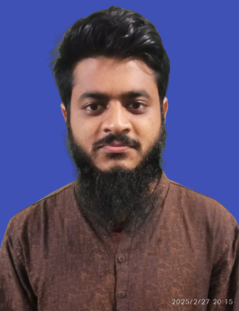**Resume of**

**S.K. Shamim Roby**

**Rangpur, Bangladesh**

Cell : +8801580487546

E-mail : shamimroby@gmail.com

I am a young learner with high ambitions and looking for challenging opportunities where I will have the scope to utilize my communication skill, Adaptability, leadership quality and all the competencies I have, to do something innovative and from where I will be able to enhance my knowledge and experience.

**Educational Qualification**

**01. Bachelor of Arts (BA)**

Name of Institution : Begum Rokeya University, Rangpur

Department : Bangla

Examination year 2023

Result : CGPA 3.46 out of 4.00

**02. Higher Secondary Certificate (HSC)**

Name of Institution : Sunflower School and College, Saidpur

Group : Science

Board : Dinajpur

Examination year 2019

Result : GPA 4.92 out of 5

**03. Secondary School Certificate (SSC)**

|  |  |
| --- | --- |
| Name of the school | : Al-Faruque Academy, Saidpur, Nilphamary |
| Group | : Science |
| Board | : Dinajpur |
| Examination Year | 2017 |
| Result | : GPA 4.64 out of 5 |

**Skill**

• Basic Computer Skills include MS Word, MS Excell, Power point. Digital Marketing, Graphics design, Web Development

|  |  |  |  |  |  |  |
| --- | --- | --- | --- | --- | --- | --- |
| **Language Proficiency** | | |  |  | |  |
| Sl. no Language | | | Listening | Understanding | | Speaking |
| 1. Bengali | | | Very Good | Very Good | | Very Good |
| 2. English | | | Better | Better | | Good |
| **Personal Information** | | |  |  | |  |
| Name | : S.K. Shamim Roby | | |
| Mother’s Name | : Mst. Mahamuda | | |
| Father’s Name | : S.K. Azim | | |
| Present Address | : Sardarpara ,Rangpur sadar,Rangpur | | |

Begum Rokeya University, Rangpur.

Permanent Address : Village : Saidpur, Post : Saidpur

|  |  |
| --- | --- |
| District | : Nilphamary |
| Sex | : Male |
| Height | : 5’5” |
| Weight | : 65 |
| Blood Group | : B+ (Positive) |
| Date of Birth | : 10 October 2001 |
| Marital Status | : Single |
| Nationality | : Bangladeshi (by Birth) |

I declared that all the information given in my Resume are true.